# **The 5 AI dragons of 2025 (Cheat Sheet)**

Find Your Monetisation Pathway 💸



## 

## **✅ The good news.**

The great news is that most people aren't even paying attention to AI. Like, seriously, my dentist asked me a few months ago if I've ever heard what ChatGPT is. Degree-educated people, professionals, and businesses are significantly behind. The fact that you're reading this resource means that you're in the advanced minority.

## **🏎️ Where to start**

I've put a lot of thought into it, and I've been obsessed with AI and automations for years. These are the five largest AI dragons of 2025 for driving an income. Nobody is different, and they will appeal to different individuals. But feel free to use this cheat sheet to understand where you may want to start.

## 

## **🏆 #1: AI Agency (EASIEST WAY TO YOUR FIRST $10K)**

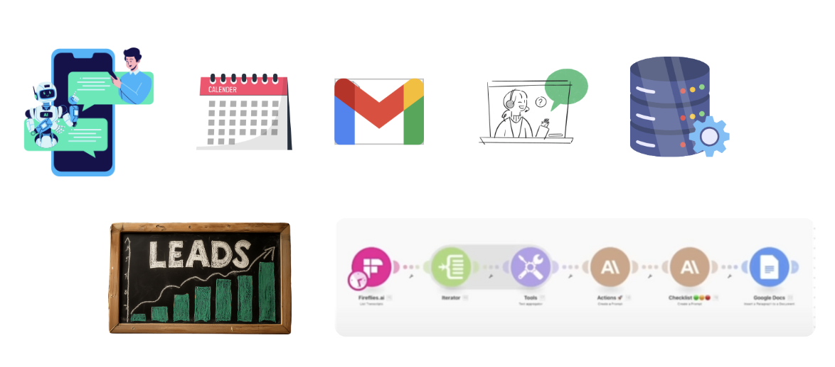

**🎯 What it is:** Solve real business problems using AI and automation for paying clients.

**👥 Who pays you:** SMBs to enterprise companies drowning in manual workflows

**💸 How you get paid:**

* Project fees: $3K-$50K+ per implementation
* Monthly retainers: $2K-$20K/month
* Value-based pricing: 10-30% of client growth (50% of cost savings)
* Hourly consulting: $150-$100/hour

**🚀 Why this wins:**

* 💰 **Immediate high revenue** (clients pay $10K+ for solutions that save them $100K)
* 📈 **Extremely scalable** (systematize and hire team members)
* 🏝️ **Low competition** (most people avoid "boring" business problems)
* 🔄 **Recurring relationships** (clients need ongoing optimization)
* 📦 **Easy to productize** (turn custom solutions into repeatable offerings)

**⚠️ The reality check:**

* ⏰ Time-intensive learning curve (3-6 months to become proficient)
* 💎You need to learn AI automations and business fundamentals
* 🤝 Client dependency (lose a big client, lose big revenue)
* 🔍 Scope creep battles (clients always want "just one more thing")

**🎯 Easiest way to:** Get your first $10K online

**❓ Key question:** *Are you willing to get your hands dirty solving unglamorous but profitable business problems?*

*TLDR: This is by far the best way to get started with AI online. There are frameworks and techniques you can use to get more clients than you'll ever need. It is chronically underserved at the moment. You don't need any background, your experience doesn't need to be great, and there are low barriers to entry. I help people get their* [*first 5 clients here*](https://bit.ly/4lRLg4o) *if you're interested.*

*An example of an AI automation agency website:*

[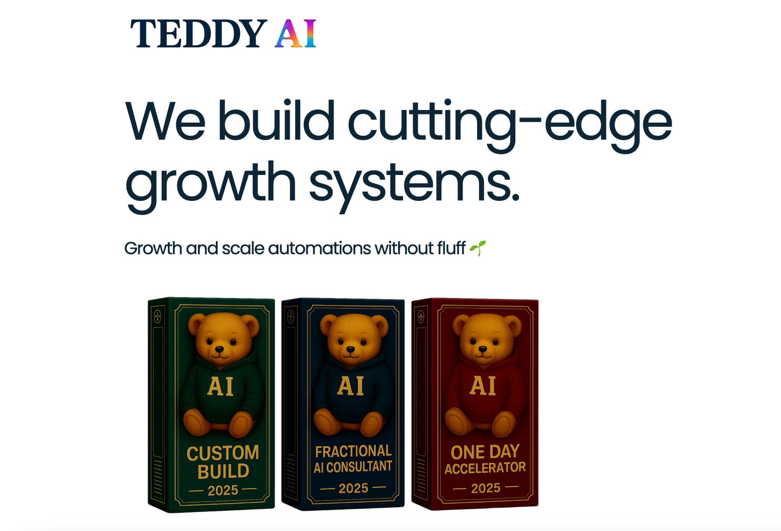](https://growwithteddy.com/)

Here's an example of some automations that sell for thousands of dollars.

[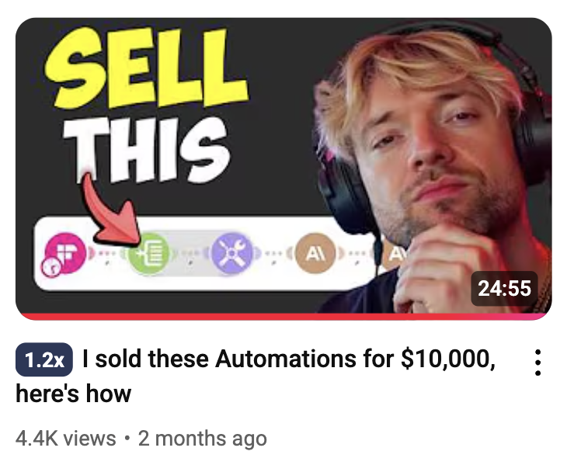](https://www.youtube.com/watch?v=F65lqiDG_g0)

## 

## 

## 

## **🛠️ #2: AI SaaS:** Slow to start, high upward potential

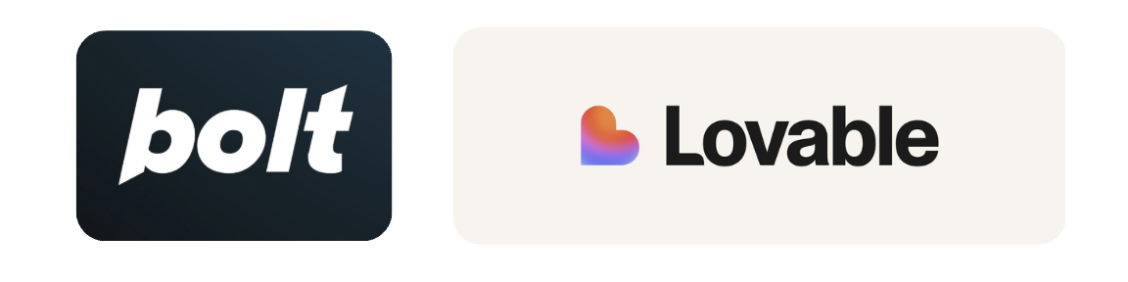

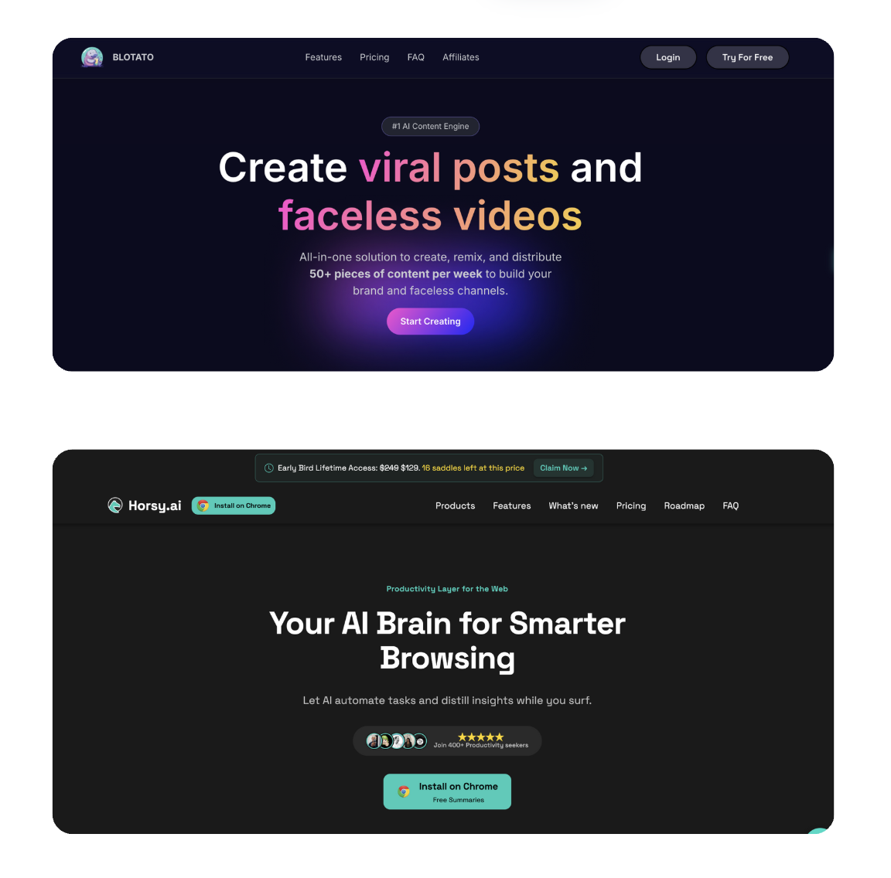

**🎯 What it is:** Build AI-powered software that solves specific problems, charge monthly subscriptions.

**👥 Who pays you:** Businesses and consumers needing your specific solution

**💸 How you get paid:**

* Monthly recurring revenue (MRR): $2-$500+ per user
* Annual subscriptions with discounts
* Freemium model (free tier + paid upgrades)

**🚀 Why it's tempting:**

* 🔄 Predictable recurring revenue once established
* 🌐 Highly scalable (software scales infinitely)
* 🎧 Lower ongoing customer service needs
* 💎 High valuations and potential exits

**⚠️ Why it's harder than it looks:**

* 💸 High upfront development costs (often 6-18 months before revenue)
* 🎯 Customer acquisition is expensive and difficult
* 📉 Monthly churn can kill your business
* 🧠 Requires product sense and technical execution

**🎯 Easiest way to:** Build a $100K+ MRR business

**❓ Key question:** *Do you have 12-18 months of runway and strong technical/product skills?*

## **📱 #3: AI Content Creation (Easiest way to get traction)**

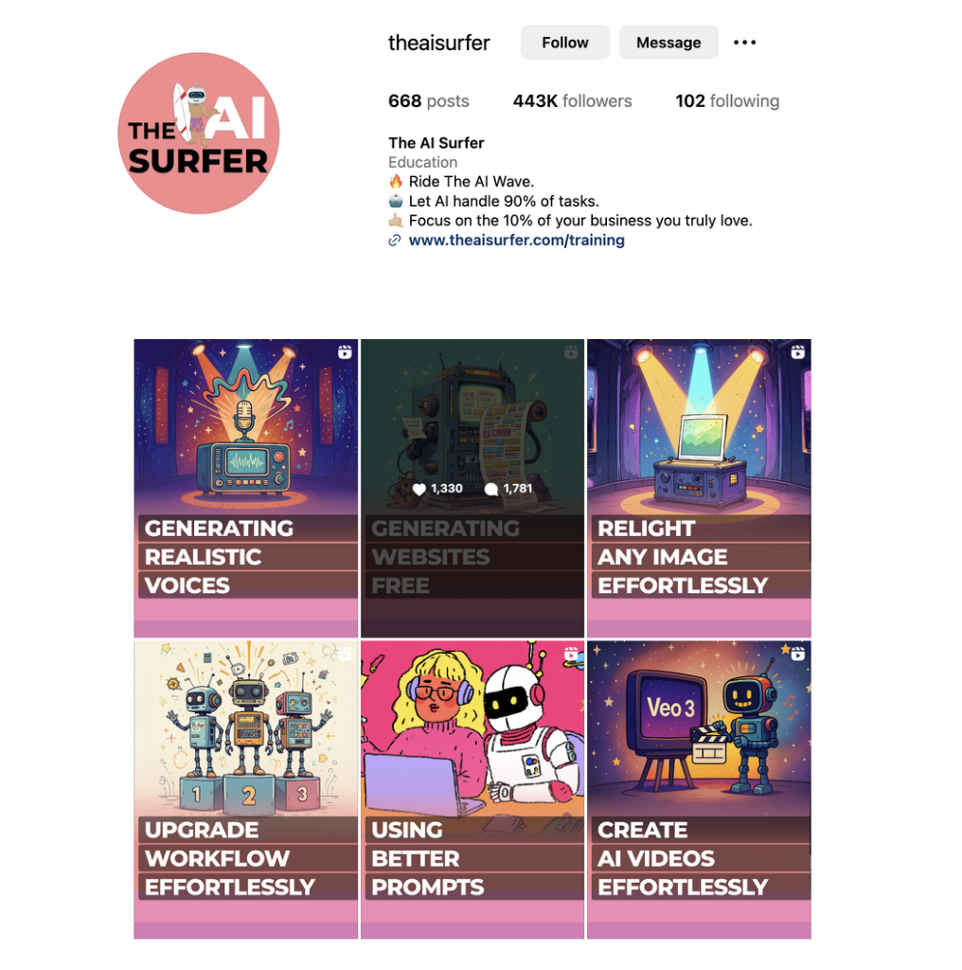

**🎯 What it is:** Create AI-generated content across platforms, monetize through ads and sponsorships.

**👥 Who pays you:** Audiences consuming your content, brands wanting promotion

**💸 How you get paid:**

* Ad revenue: $1-$5 per 1,000 views
* Sponsorships: $100-$10,000+ per post
* Affiliate commissions: 3-30% of sales
* Product sales to your audience

**🚀 Why everyone tries it:**

* 🚪 Low barrier to entry (start today with $0)
* 💰 Multiple ways to make money
* 🚀 Potential for viral growth
* 🎨 Creative freedom

**⚠️ Why most fail:**

* 🌊 Incredibly saturated and competitive
* 🎲 Algorithm-dependent income (one change kills your revenue)
* 👻 No personal brand building (you're invisible behind AI)
* ⚖️ Low leverage (more content ≠ proportionally more money)
* ⚠️ Platform risk (TikTok ban, YouTube policy changes)

**🎯 Easiest way to:** Start making money online today

**❓ Key question:** *Are you comfortable with unpredictable income and no control over your distribution?*

The reality with faceless video content is that you can get started quite easily. You just need to learn how to edit, you're following the algorithms. However, one of the significant drawbacks with this is the fact that it not only is it incredibly competitive, but you are essentially trying to hack and find ways around it.

Individuals like the AI Surfer have been able to develop a brand off the back of it. But in my personal view, it is the lowest leverage of all the things that you can do on this list.

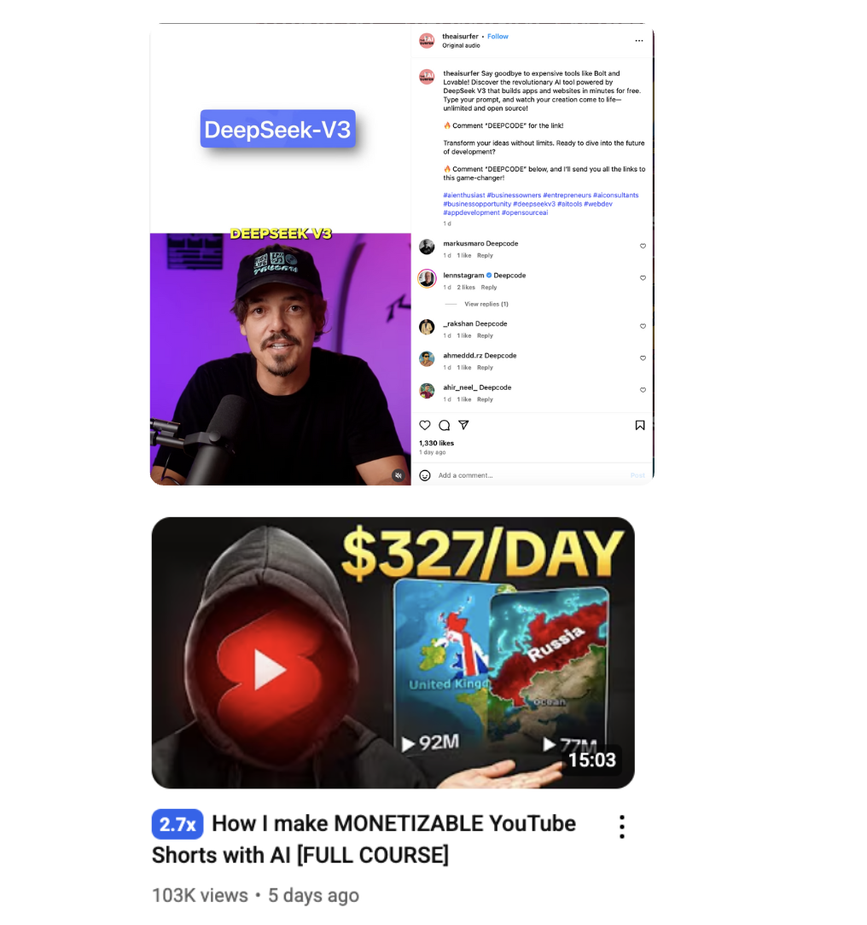

## **🏢 #4: Corporate AI Champion (Easiest way to increase your salary with low risk)**



**🎯 What it is:** Become your company's AI expert, leading internal AI initiatives and implementations.

**👥 Who pays you:** Your current employer

**💸 How you get paid:**

* Salary increases: 20-50% bumps for AI expertise (new roles)
* Promotions to AI leadership roles
* Bonuses tied to successful AI implementations
* Stock options in AI-forward companies

**🚀 Why it's the safe choice:**

* 🤝 Leverage existing relationships and company knowledge
* 🛡️ Lower risk while building expertise
* 📈 Clear career progression path
* 🏗️ Company resources for experimentation
* 💰 Steady paycheck with no entrepreneurial stress

**⚠️ Why it limits you:**

* 🔒 Capped by company's AI budget and vision
* 🐌 Slower income growth than external opportunities
* ⚡ Single point of failure (company layoffs, strategy changes)
* 🎯 No ownership of your career trajectory

**🎯 Easiest way to:** Get a 50% salary increase

**❓ Key question:** *Are you prioritizing security over potential wealth creation?*

*Growing a business is one of the most rewarding things in the world. Can provide infinite income. For example, take a look at the Cash flow quadrant from Robert Kiyosaki below. If you really want to make exponential income, you want to be on the right-hand side, in other words, you want to be a business owner or an investor. However, that does come with stress and risk.*

*This is an incredible way to get started and grow an income and apply significant value to an existing business.*

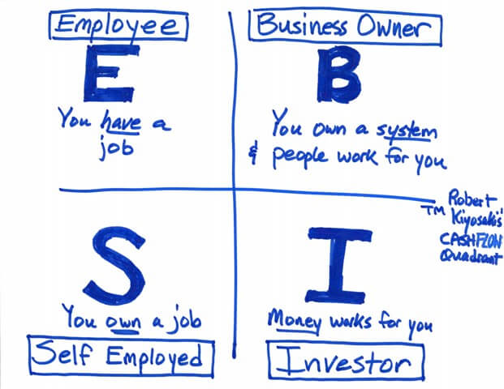

## 

## 

## **🎓 #5: AI Education (Easiest way to build authority)**

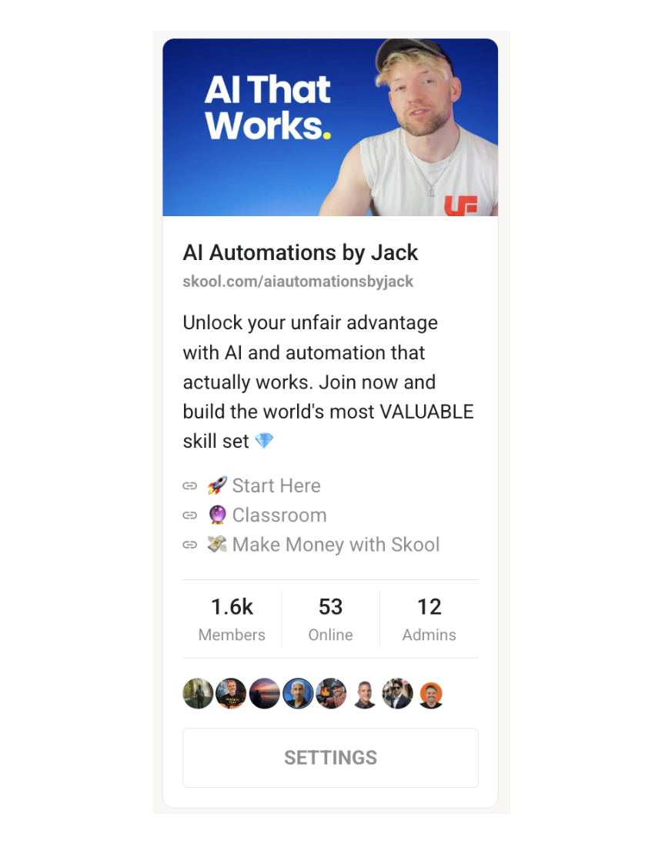

**🎯 What it is:** Teach others how to use AI through courses, coaching, and communities.

**👥 Who pays you:** AI-curious individuals, small business owners, professionals

**💸 How you get paid:**

* Online courses: $20-$2,000+ per student
* One-on-one coaching: $100-$1,000/hour
* Community memberships: $50-$200/month
* Speaking engagements: $5K-$50K per event

**🚀 Why it seems appealing:**

* 📊 High profit margins on digital products
* 👑 Positions you as an expert and thought leader
* 🌐 Scalable content delivery
* 💰 Multiple revenue streams

**⚠️ Why it's getting harder:**

* 🌊 Extremely saturated market (thousands of AI course creators)
* 🔄 Requires constant content updates as AI evolves rapidly
* ⏰ Building audience and credibility takes 12-24 months
* 📉 High churn rates in education

**🎯 Easiest way to:** Build authority and become a thought leader

**❓ Key question:** *Do you have unique expertise and the patience to build an audience from scratch?*

We're in phase II of the AI educator economy, and the focus now is to find a niche that aligns perfectly with your skill set and serve that niche. There are more people every day that need it, although it is very competitive. I find this discussion I had with Stephen Pope helpful on the AI character economy.

You can [build a community here](https://www.skool.com/refer?ref=d4618abaabee44c7ac3c146938a72100).

[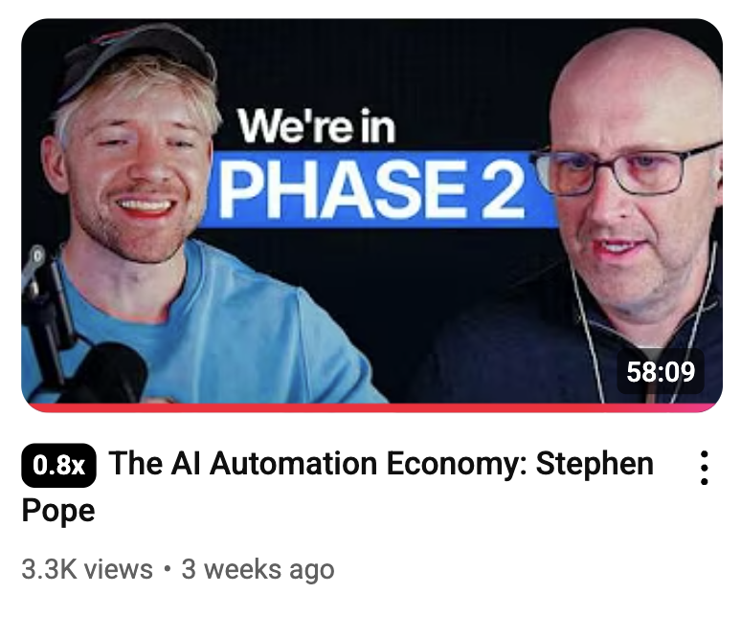](https://www.youtube.com/watch?v=c6KIsvgguf0)

## 

## 

## **Which Path Should You Choose?**

It's difficult to content just on just a couple of questions, but if I had to, this is a great way to think about it.

### **💰 If you want to maximize income potential: AI Agency**

* 🚀 Highest immediate earning potential
* 📈 Most scalable with team building
* 🏝️ Least saturated market

### **🛡️ If you want predictable income: Corporate AI Champion**

* 💰 Steady paycheck while learning
* 📉 Lower risk profile
* 🪜 Good stepping stone to other paths

### **🛠️ If you have technical skills and patience: AI SaaS**

* 💎 Highest long-term value creation
* 👨‍💻 Best for technical founders
* 💸 Requires significant upfront investment
* 👀Will give you great long-term upside but will not make you rich in the short term.

### **🎨 If you want creative freedom: AI Content Creation**

* 🚪 Lowest barrier to entry
* 🎢 High volatility and competition
* 💡 Best as side income, not primary strategy

### **👑 If you're already an expert: AI Education**

* 🎯 Good for established experts with audiences
* ⏰ Requires significant time investment to build credibility
* 🔗 Works well combined with other paths

## **🎯 The Bottom Line**

**🏆 IMO the AI Agency path wins because:**

1. 💰 **Immediate revenue potential** (close deals in weeks, not years)
2. 🏝️ **Less competition** (most people avoid B2B sales)
3. 🔄 **Recurring relationships** (clients need ongoing optimization)
4. ⚙️ **Easy to systematize** (turn custom work into repeatable processes)
5. 📊 **High margins** (your expertise commands premium pricing)

The question isn't which path is easiest. It's which one aligns with your risk tolerance, timeline, and skills. But if you want to make serious money with AI in the next 12 months, become the person who solves real problems for real businesses. Remember, you're still winning and you're ahead of most people just even by looking at this document.

You've got this!

Love and Automation,

Jack 💙🤖